Methods Unit 3 Test 1, 2018

(Calculator Free)

Time: 20 minutes Marks: 20

Name ________________________________

1. [2, 2, 2 marks]

Determine $\frac{dy}{dx}$ for each of the following but **do not simplify**:

1. y = (2x - 3)(1 - 4x)3
2. y =
3. y =
4. [2, 2 marks]

Determine the following integrals, expressing in their simplest form:

a)

b)

3. [1, 4, 2 marks]

For the curve y = $\frac{x^{2}}{x-2}$

a) State the equation of the vertical asymptote.

b) Show that this curve has two stationary points, and state the coordinates.

c) Given that $\frac{d^{2}y}{dx^{2}}$ = $\frac{8}{{(x-2)}^{3}}$ determine the local minimum.

4. [3 marks]

Given that y = $\frac{x-1}{x-2}$, use the incremental formula to determine the approximate change in y, as x increases from 4 to 4.01.

 Methods Unit 3 Test 1, 2018

(Calculator Assumed)

Time: 40 minutes Marks: 40

Name ______________________________

5. [2, 2, 4, 3 marks]

The velocity of a particle is given by v(t) = t2 – 2t – 8 m/sec. Initially, the particle has a displacement of

2 m.

a) When is the particle stationary?

b) When is the acceleration zero?

c) Determine the displacement when the particle is stationary.

d) How far did the particle travel in the first 6 seconds?

1. [6 marks]

The equation of the tangent to the curve y = (ax - 3)3 – 2 at the point (1, 6) is y = bx + c.

Determine a, b and c.

1. [2, 7 marks]

A wire frame is constructed as indicated in the diagram below. 48 cm of wire is required to make it.

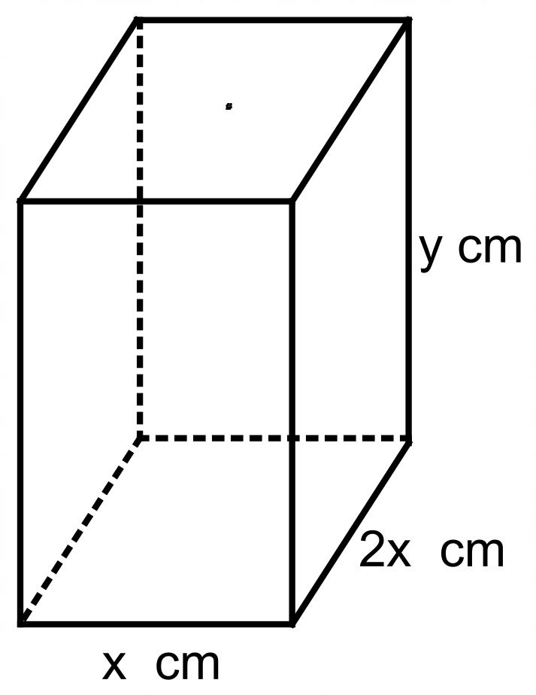

a) Show that y = 12 – 3x.

b) Determine the dimensions of the box and its volume, such that the volume is at a maximum.

8. [3, 3, 3 marks]

Consider the curve y = x3 – 6x2

a) Use calculus to determine the point of infection of the curve.

b) State the interval(s) for which the curve is concave down. Show reasoning.

c) Sketch the curve below, clearly labelling all critical points with coordinates.

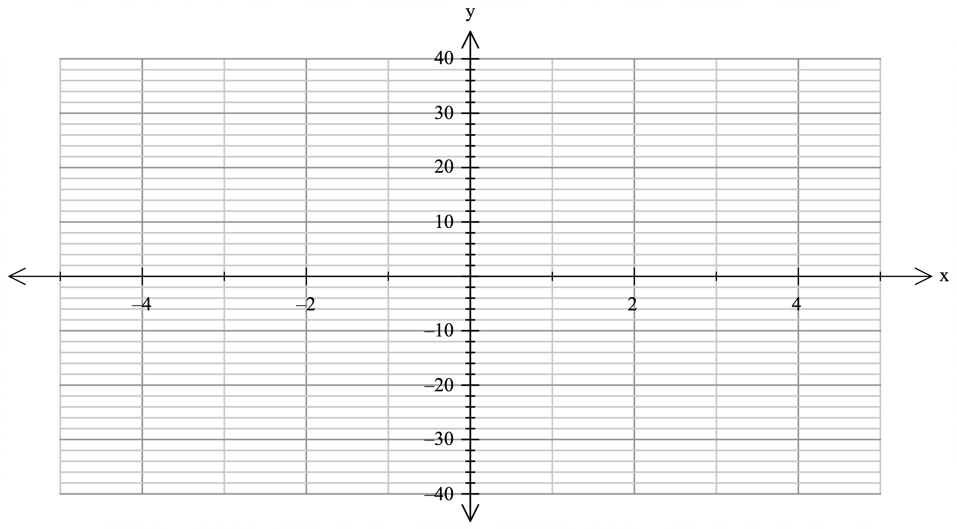

9. [5 marks]

Given that f ‘(x) = $\frac{4}{{(2x-1)}^{2}}$ and that f(1) = 4, determine f(0). Show all reasoning.